5 SQUARES

A plane consist of squares. Remove in each vertex one square (removed squares are black). The most obvious solution is given in figure 1. It is possible to move the horizontal rows with black squares one step or the vertical columns with black squares one step. If one makes the decision to move at least one horizontal row then no vertical column can be moved. Of course other horizontal rows can moved one step.

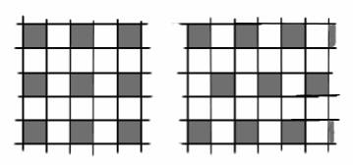

{4,5} 10

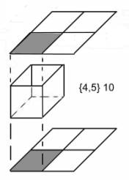
Elementary cell consist of an array of 4 squares (1 removed, black), a cube with the bottom and the top removed on the black square, and on top an array of 4 squares (1 removed, black).
In total 3+4+3 = 10 squares.

There are two different versions.
(different sets of translation vectors)

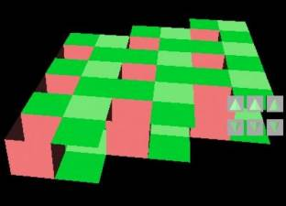
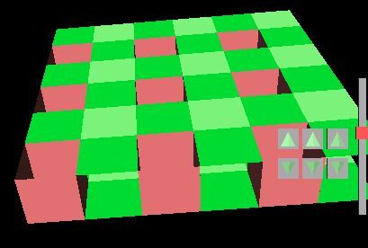

vrml-model vrml-model
(4_5flat_leo.wrl) (4_5b_flat_leo.wrl)

{4,5} 20
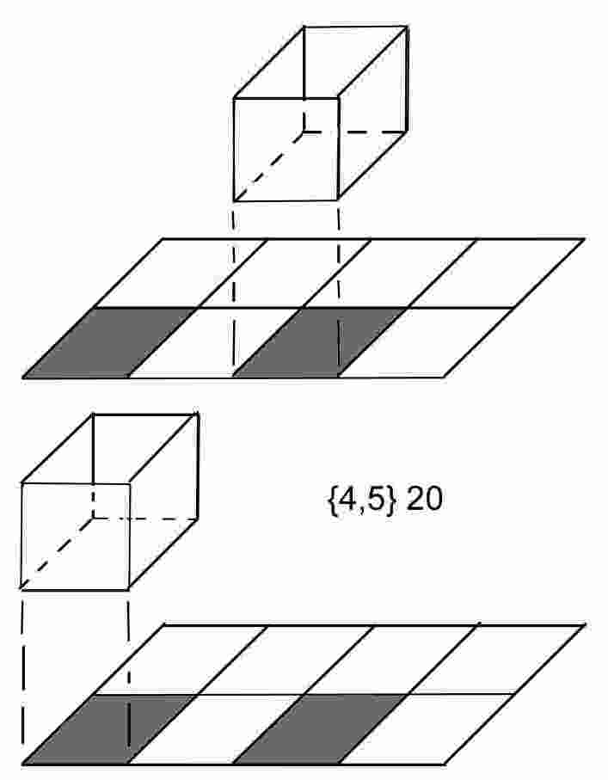
Elementary cell consist of an array of 8 squares (2 removed, black), a cube with the bottom and the top removed on one of the black square, an array of 8 squares (2 removed, black) and a cube without top and bottom on the other square . In total 6+4+6+4 = 20 squares.
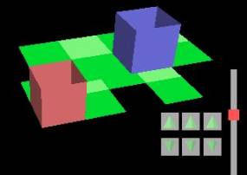

vrml-model (4_5e_leo.wrl)

{4,5} 20
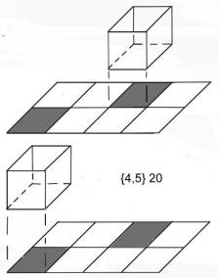

Elementary cell consist of an array of 8 squares (2 removed, black) in a somewhat different situation. Etc, etc…..

There are two versions.

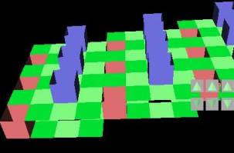
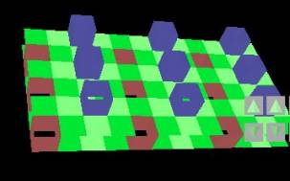

vrml-model vrml-model
(4_5m_leo.wrl) (4_5f_leo.wrl)

